Directions: Completely factor the following polynomials. If a polynomial does not factor write, “Does not factor.”

1) 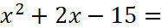 2) 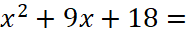

3) 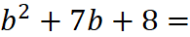 4) 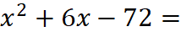

5) 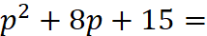 6) 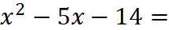

7) 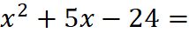 8) 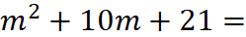

9) 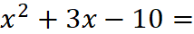 10) 